Subject: Kakehashi Project 2015 – Asian American Leadership Delegation to Japan

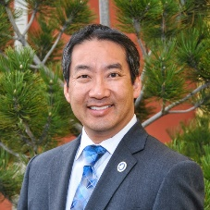
Mr. Clarence Low, President and CEO of the Asian Chamber of Commerce of Colorado, participated in the second annual Asian American Leadership Delegation to Japan in December, 2015. Called the Kakehashi Project, a delegation of ten Asian-American leaders from around the United States was hosted by the Ministry of Foreign Affairs of Japan. This program provided opportunities to engage with Japanese leaders in government and business, and gain a better understanding of policy issues and challenges facing Japan. Delegates also experienced Japan’s society, history and culture through visits to a number of districts around Tokyo, Kyoto and Hiroshima.

Several guides from the Japan International Cooperation Center (JICE) received traveling delegates and provided exemplary coordination and logistics for the visits to numerous offices and cities.

Delegates received briefings that included:

- Japan’s foreign policy and domestic challenges and opportunities;
- Japan’s long-term care insurance system;
- Reconstruction efforts in the Sendai, Tohoku earthquake/tsunami-affected areas;
- Japanese territorial and sovereignty challenges in the South China Sea;
- Gender equality opportunities within corporate and governmental positions; and
- Fuel cell technology and innovations from Toyota Motor Corporation

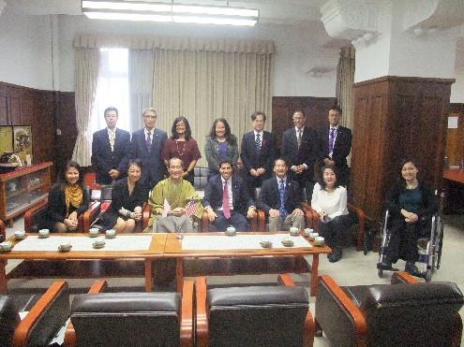
Delegates were also graciously received by Mr. Yoji Muto, State Minister for Foreign Affairs in Tokyo as well as Mr. Daisaku Kadokawa, Mayor of Kyoto. One of the delegates, Mr. Daniel Koh, who serves as the Chief of Staff for the Mayor of Boston, Massachusetts, exchanged remarks and gifts honoring its International Sister City relationship between Kyoto and Boston.
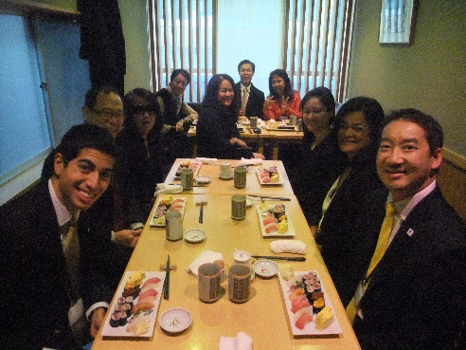
Beautifully-presented dinners were hosted by members of the Ministry of Foreign Affairs. Additionally, the delegation had opportunities to experience delicious cuisine, including a traditional Japanese breakfast, blowfish, sushi at Tsukiji Fish Market, keiseki, oysters from Hiroshima, and shabu-shabu.

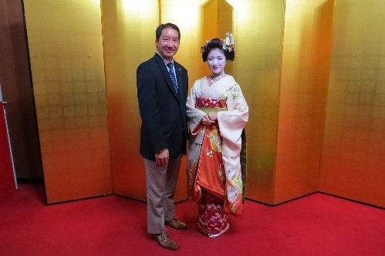
Other notable opportunities to experience Japan included traveling to Hiroshima and Kyoto by Shinkansen (bullet train), visiting the National Diet building, participating in a special ceremony at the Meiji Shrine, visiting Hiroshima Peace Memorial

Park, visiting the Temple of the Golden Pavilion, sake tasting at Gekkeikan Brewery and taking in traditional dance and music performances at Gion Corner.

The Asian Chamber of Commerce appreciates the nomination for the Kakehashi Project from the Consulate-General of Japan in Denver, and for its continued efforts and support building deep relationships between countries.

