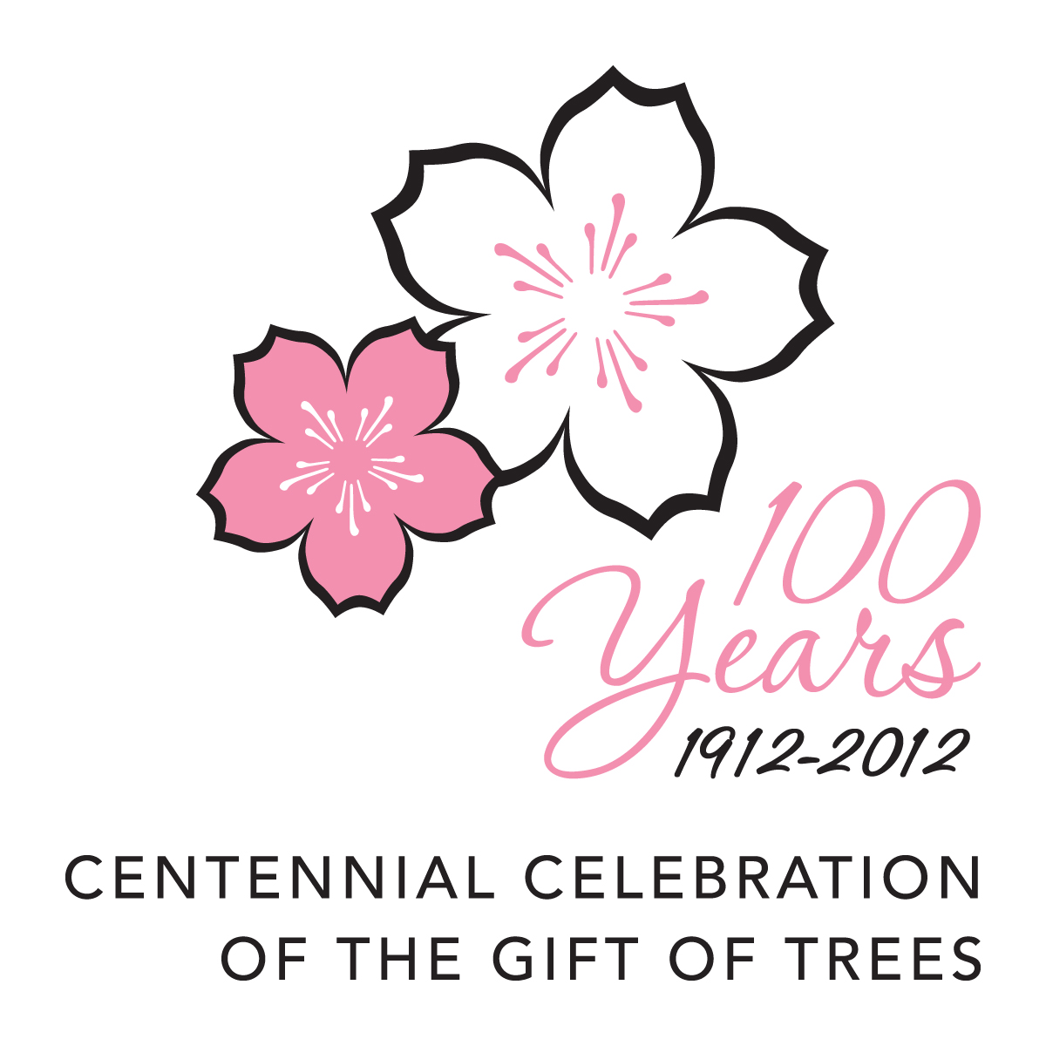
Japan –U.S. Cherry Blossom Festival Centennial
CENTENNIAL LOGO APPLICATION

The Embassy of Japan in the United States and all the Consulates-General in the United States (hereinafter “we”) appreciate your organization’s interest in the Centennial Celebration by requesting use of the Centennial Logo.
We will review the information that you provide in this application according to the terms of acceptance below. If we accept your application, you will be issued the Centennial Logo for use.
You may use the Centennial logo after you receive its files. In addition, the event of your organization will be a part of the Japan- U.S. Cherry Blossom Centennial.

Terms of Acceptance

1. In general, the event shall be organized between January 1, 2012 – December 31, 2012.

2. The event shall be contributing to promoting mutual interaction, enhancing mutual understanding, and strengthening friendship in various fields between Japan and the United States of America.

3. The content and aim of the event shall be easily comprehensible and the event shall be highly realizable.

4. The activity shall not be aimed at promoting a certain ideology, conviction or religion; and shall not be damaging public order and moral values.

5. The organizing body shall be responsible for all aspects –including all expenses- of the event.

Section A
*Incomplete applications will not be accepted.
*Additional documents can be annexed, if necessary.

Title of the event※
Organizer ※
Organizer ※ | Please place X mark  □ governmental organization □ local government □ public-service organization  □ school □ private enterprise  □ cultural organization □ private nonprofit organization  □ others（ ）
Name and Title of
the person in charge
Contact information of  the Organizer  （All items have to be filled in ） | Address ：
 | Name of Contact Person： | E-mail ：
 | Telephone ： | Fax ：
Content of the event
Time and Date / Period | Year / Month / Date ～ Year / Month / Date
Place
Area of the event | Please place X mark（ more than one item can be chosen）.  □ politics □ economy □ science/technology □tourism □ Japanese Dishes □movie  □ performance □ theatre □ music □ photo □ lifestyle □ health/ exercise  □ fine art □ education □ academic project/ research □ sports □ exchange of the youth  □exchange project between regional cities  □others（ ）
Outline of the event | Please place X mark（ more than one item can be chosen）.  □ festival □ concert □ exhibition □performance □ meeting □seminar/ lecture  □ workshop □ competition □ people-to-people exchange □ training □ volunteer  □ TV program □ movie/ video show □ internet □ book  □others（ ）
Co-organizer/Sponsor | Japanese :
Co-organizer/Sponsor | English :
Please place X mark.
□ The event belongs to a lager / comprehensive project (example：○○ Festival, ○○ Symposium etc).
→【Title of the Project： 】
□ The event is an independent one.
Means for securing funds for the event | Please place X mark（ more than one item can be chosen）.  □ subsidy from official organization □ sponsor from private enterprises □donation  □ charging entrance fee □ membership fee □ self-financing of organizer  □ others（ ）
Current stage of  the preparation | Please place X mark（ more than one item can be chosen）.  □ all confirmed  □ in the planning stage □ in the conceptual stage  □ others( ）
Proposed Uses/ Placement of Centennial Logo
others

Signature

I, the undersigned, have read and understood this Application. I am authorized to sign on behalf of the Applicant, and have provided true and accurate information on behalf of the Applicant.

I understand that
a) the Embassy of Japan in the United States and all the Consulates-General in the United States (hereinafter “the Embassy/ the Consulates-General”) will review this application but is under no obligation to accept it;

b) the Embassy/ the Consulates-General will notify me if they accept the application and provide me with the Centennial Logo for usee;

and c) the Embassy/ the Consulates-General can freely withdraw the approval upon finding a violation of any obligations prescribed in this application.

Upon signature of this document, I agree that, should I be approved and receive the Centennial Logo, I will
a) not use the Centennial Mark on commercial projects or in association with for-profit endeavors (i.e. merchandise, travel packages, etc.);

b) use the camera-ready art of the Centennial Logo that the Embassy/ the Consulates-General provide;

c) not modify the Centennial Logo in any way; and

d) provide the Embassy/ the Consulates-General with drafts of my proposed Centennial Logo uses for prior approval.

By: ___________________________________________

Print Name: ____________________________________

Title: __________________________________________

Date __________________________________________

Send completed applications to:
The Consulate-General of Japan in Denver
Contact: Kayuki Takei (Ms.)
1225 17th Street, Suite 3000
Denver, CO 80202 USA
Phone: 303-534-1151 Fax: 303-534-3393
E-mail: kayuki.takei@mofa.go.jp

